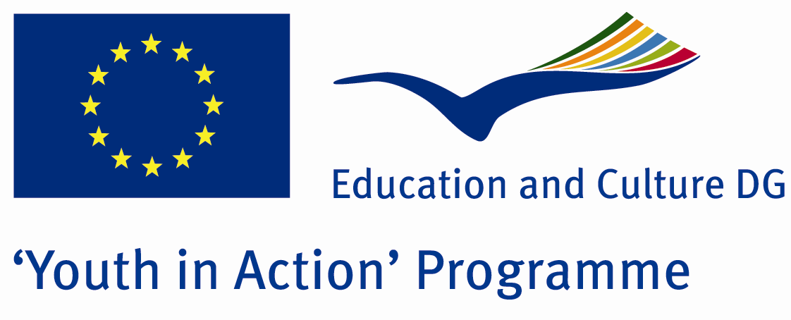

Hearth is a Bridge



ACTION 1.1 – Youth Exchange

28 July - 04 August 2011

Osmaniye, TURKEY

ACTION 1.1 - Youth Exchange
28 July – 04 August 2011
Osmaniye, TURKEY

Please contact directly to;
adventurerpeacepigeons@gmail.com

Project Summary;

Natural disasters, and major destruction occurred without the influence of people killing people and property damage by natural events. These are drought, famine, severe cold weather, earthquakes, floods, landslides, avalanches, storms, hurricanes, volcanoes, forest fires and etc. Natural disasters, most countries have not known in advance caught unprepared, so the higher losses of life and property. These disasters occur all over the world, and collaborate, and improves the support of the people. Many countries help to get rid of this disaster and lots of people make a bridge, heart to heart.

The aim of our project is prepared for natural disasters, deliberate and cold-blooded people who will help in such situations is to create. So that each participant adds a wood this bridge.

If you want to join this project, please contact us..

Project Title; Hearth is a Bridge

Date and Venue ; 28 July – 04 August 2011 Osmaniye, Turkey .

Target Group ; Municipalities, City Councils and Non-Governmental organizations,
youth groups,culture and art groups,e.t.c

Participants ; 5 people from each country (over 18 -25 ). Totally 8 countries.

Conditions ; Accommodation, board and programme costs will be financed through European Commission Youth in Action Programme (Action 4.3). Travel costs will be reimbursed in 70% (APEX Tarrifs). Organizations from all 27 EU member countries plus Liechtenstein , Norway and Iceland are eligible to take part.

Working language: English

Organizer; Adventurer Peace Pigeons

How to apply: If you are interested, please send your Part III forms to
0090 216 494 39 98 by FAX please. (Fulfilled Part III which you can find in the attachment, of course signed and stamped) ..

Note: jpeg is not allowed..please send by fax…

Next step 2;
Original send via regular post to this address please:

Ertan DERİN
Öner İnşaat
Abdulhalik Renda Cd.
Parlar Sk. No:4 Pendik/İSTANBUL

If you have any questions you may contact with: adventurerpeacepigeons@gmail.com

Deadline for application; until 20 March 2011.

For Further information:
Contact Person
Ertan DERİN
Öner İnşaat
Abdulhalik Renda Cd.
Parlar Sk. No:4 Pendik/İSTANBUL

e-mail : adventurerpeacepigeons@gmail.com
Mobile : 0090 542 393 93 90
Fax : 0090 216 494 39 98

